4235716 - Division - Auto-append division number in import
Division enhancement: Automated Division Number Appending for Spreadsheet Import (Epic 4235716)1. Customer Problemmanually edit account numbers to append division digits before import, which is tedious and error‑prone.
2. Customer Researchadd a division dropdown in import for divisional engagements; honor mask positions (DD*, *DD, CCDDCC).
3. Our SolutionImport UI: choose division (number+description); transform account numbers per mask during import.
- Preserve source data; log transformed results.
Dependencies: import pipeline, mask service, engagement props.
4. Product MetricsPre-import spreadsheet edits: -100%.
- Import error rate due to number mismatch: <1%.
Appendix: Child Features4235757 Context-Aware Division Selection UI for Spreadsheet Import
- 4235759 Dynamic Account Number Transformation
Appendix: LinksHYPERLINK "https://dev.azure.com/tr-tax/TaxProf/_workitems/edit/4235716"Open Epic 4235716

Appendix: Quick prototype
Figure: PDF page 67
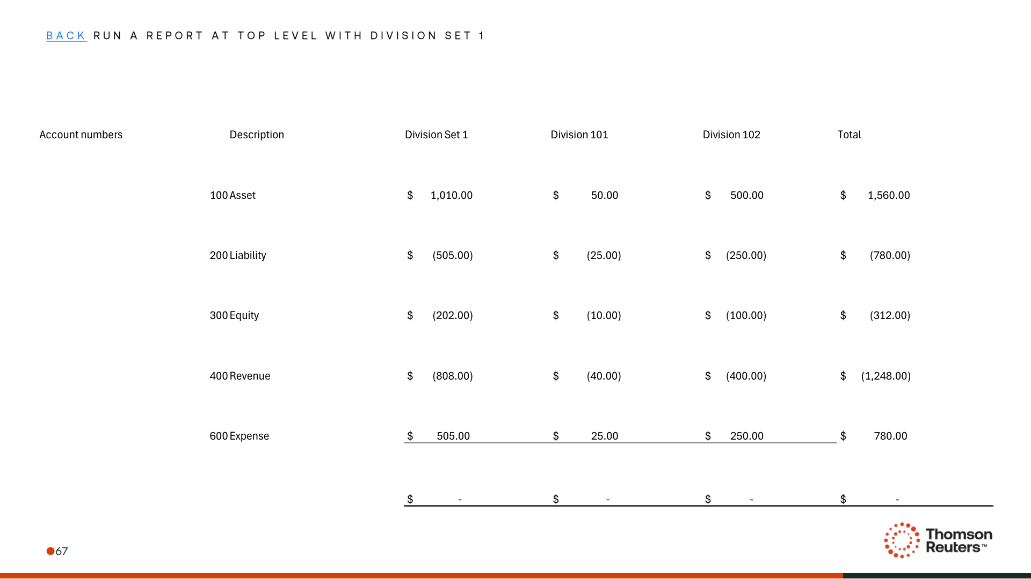
Figure: PDF page 71
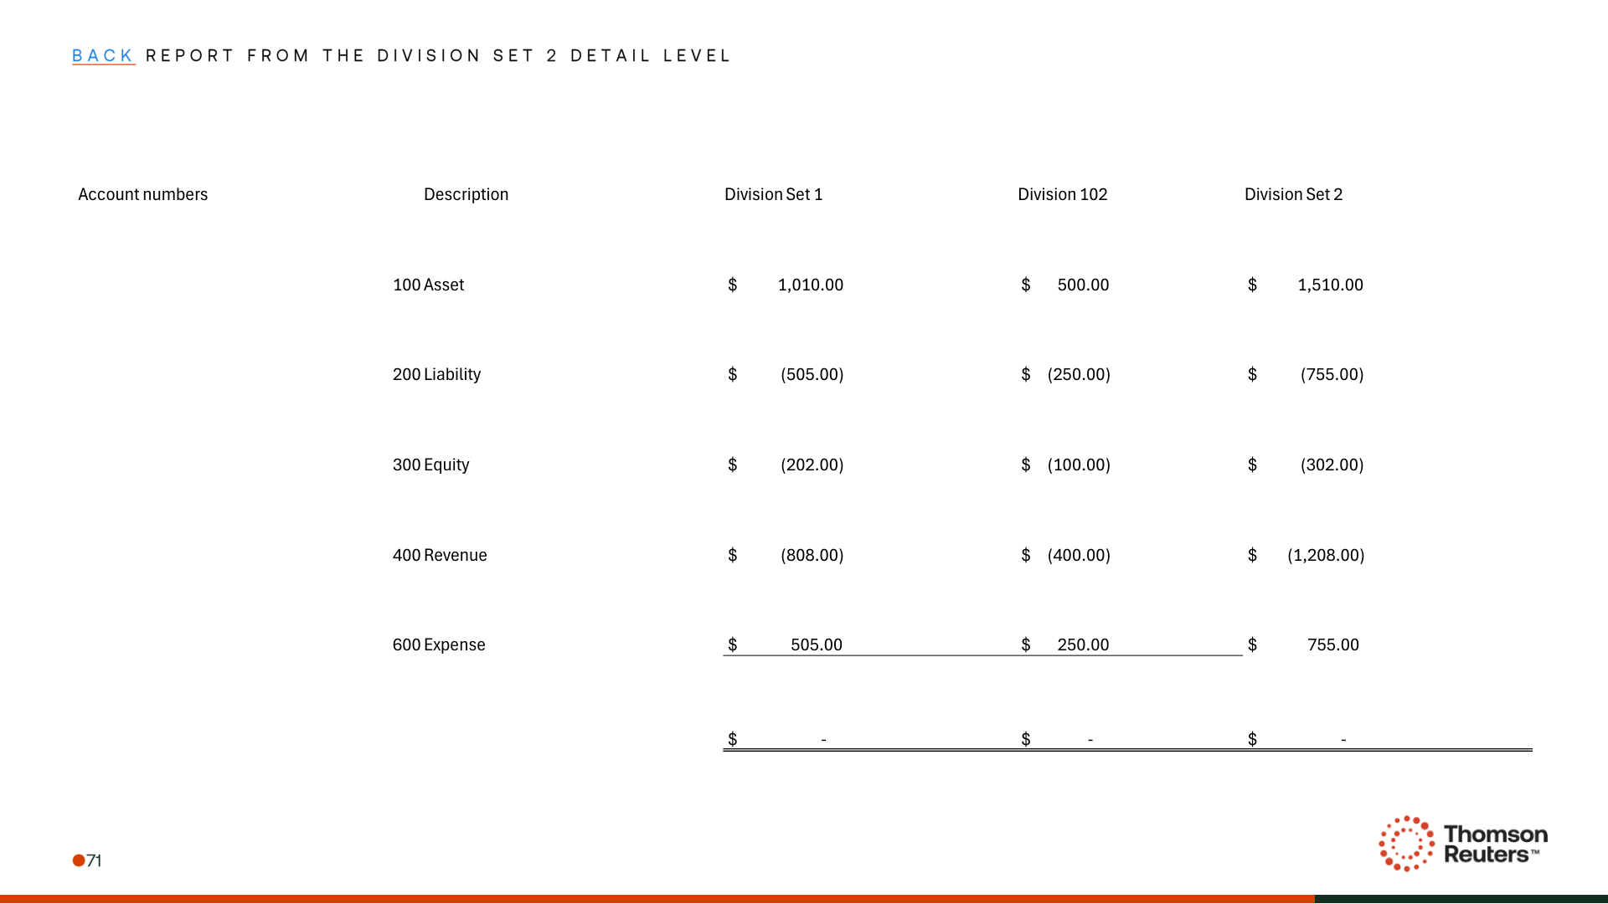
Figure: PDF page 72
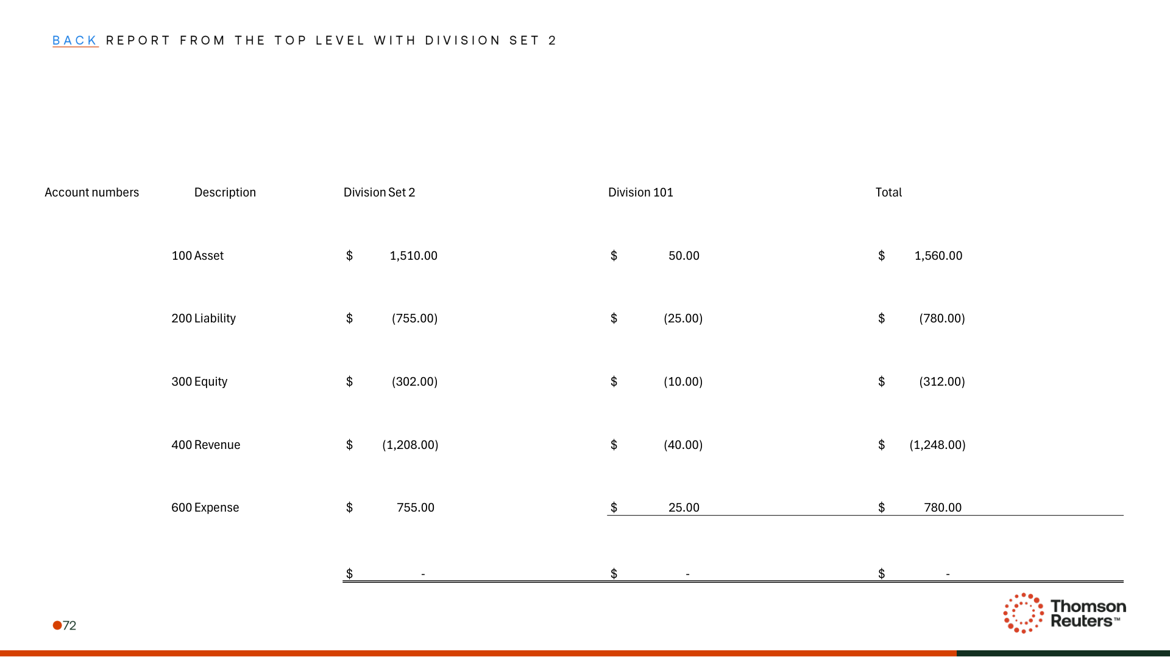

Appendix: Links
ADO Epic Link: https://dev.azure.com/tr-tax/TaxProf/_workitems/edit/4235716

